NOTICE IS HEREBY GIVEN OF THE CASTLE ACRE PARISH COUNCIL MEETING TO BE HELD AT CA VILLAGE HALL ON FRIDAY 21st AUGUST 2026 FROM 19:00-21:00, REGARDING THE FOLLOWING BUSINESS: Proposed Local Industrial Solar Sites

- INTRODUCTION from the Panel: Chair: Tim Hubbard, James Wild MP, Anne Mason, Ilga Chakrabarti & Tony Morgan.

- Chair gives welcome to all residents & Cllrs attending from Castle Acre, South Acre, West Acre.

- Panel members to give a brief summary of views (approx…3 minutes)

- James Wild introduces potential topics to be covered; audience members may ask questions, but there will be a maximum of ten minutes per topic.

- The proposals: The Droves and High Grove Solar Sites.
- Connection Substations and BESS Storage.
- RAF Marham and Impact.
- Castle Acre, South Acre Heritage and landscape impact .
- Environmental impacts.
- Construction, period, traffic and noise, deer management, road safety (A1065).
- Possible Community benefit.
- Local Community concerns, well-being, property values.

- CONCLUSION.

James: Confirming steps community can take and project timescales.
Chair: Thanks to all for attending.
Signed:
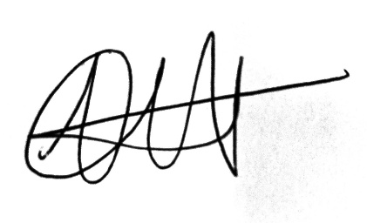

Dated: 14/08/2026

Next CAPC meeting: Thursday 10th September at 19:30 in the CA Village Hall.

